_{NIKE PRO WAIST WRAP}
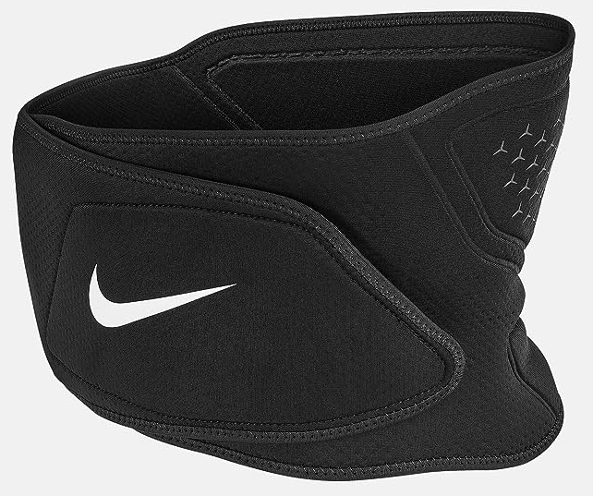
PRICE: Approximately Rs. 4,499

_{Introduction:}
The Nike Pro Waist Wrap is a supportive training accessory designed to provide stability and compression during workouts and physical activities. Engineered to help protect the lower back and core, this waist wrap offers adjustable support that enhances confidence while lifting, training, or performing high-intensity exercises. Its ergonomic design ensures a secure yet comfortable fit, allowing freedom of movement without compromising support. Ideal for athletes, gym-goers, and fitness enthusiasts, the Nike Pro Waist Wrap combines functionality, comfort, and durability to help you perform at your best.
Product Overview:
The Nike Pro Waist Wrap is designed to deliver firm yet flexible support to the waist and lower back. Featuring an adjustable closure system, it allows users to customize the fit according to their comfort and training needs.
About the Brand:
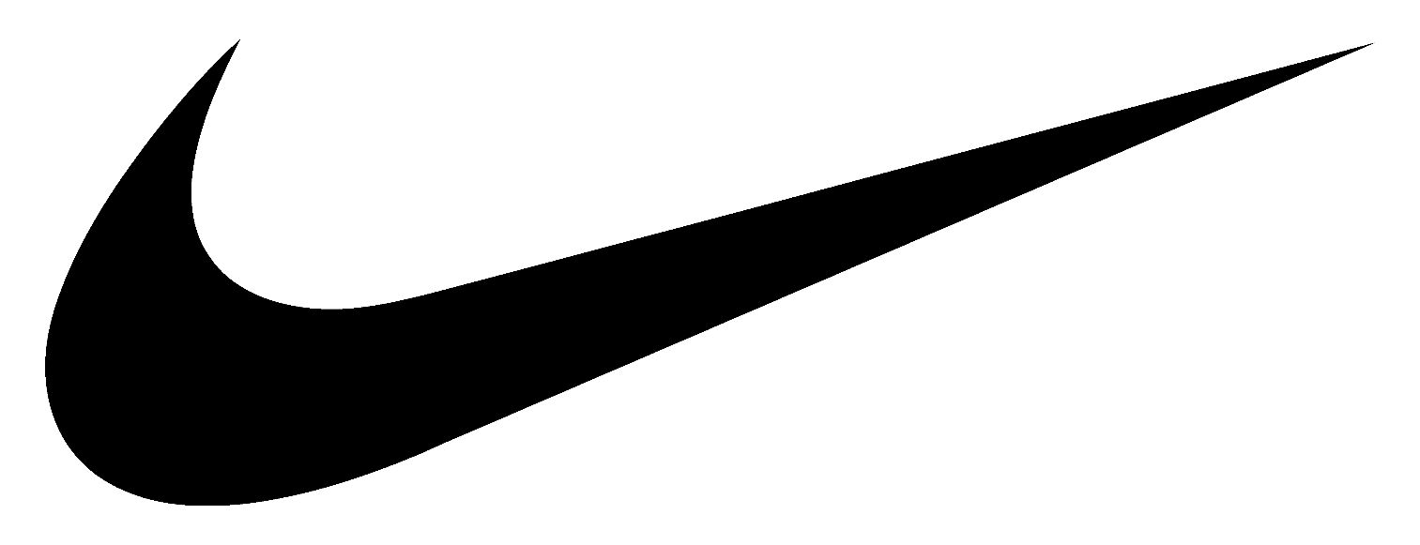
Nike is a world-leading sportswear brand known for innovation, performance, and iconic design. With decades of experience in athletic footwear and apparel, Nike continues to set global standards in comfort, durability, and style for athletes and lifestyle users alike.

Key Features:
- Provides stability to the waist and lower back
- Breathable material for enhanced comfort
- Secure fastening for a snug fit
- Lightweight and flexible design
- Suitable for various training activities
- Tighten the Waist completly

Design & Build Quality:
The Nike Pro Waist Wrap features a streamlined and ergonomic design that contours naturally around the waist. Reinforced stitching and high-quality materials ensure durability, while the flexible structure allows unrestricted movement during workouts.
Storage & Capacity:
The waist wrap is compact and easy to store when not in use. Its lightweight design allows it to fit easily into gym bags or backpacks, making it convenient to carry for workouts, training sessions, or travel.
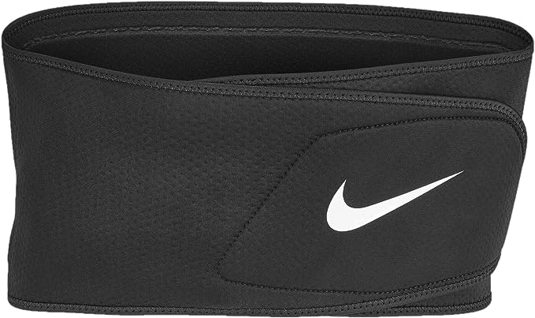

Material & Durability:
Made from durable elastic and breathable fabric, the Nike Pro Waist Wrap is built to withstand regular training use. The material maintains its shape and elasticity over time, ensuring long-lasting performance and reliable support.
Ideal For:
- Weight training and gym workouts
- Core exercises and functional training
- Athletes requiring waist and lower back support
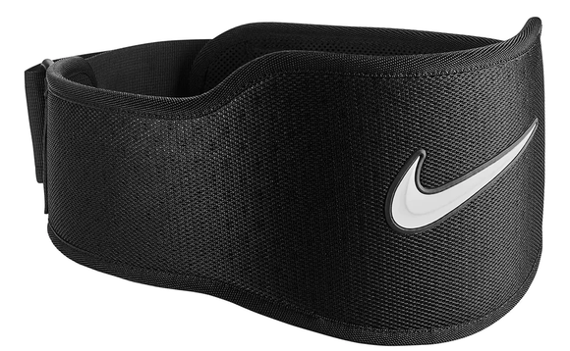
- Fitness enthusiasts seeking added stability

Care Instructions:
- Hand wash with mild detergent
- Do not bleach or machine wash
- Air dry away from direct heat
Product Specifications:
- Brand: Nike
- Product Type: Waist Support / Training Wrap
- Material: Elastic and breathable fabric
- Closure Type: Adjustable fastening
- Fit Type: Adjustable / One size fits most
- Usage: Training and workout support

Product Summary:
The Nike Pro Waist Wrap offers reliable support, comfort, and durability for training and fitness activities. Designed to stabilize the core and lower back, it is an essential accessory for athletes and gym users who prioritize safety and performance during workouts.

